Document Object Model

A Document Object Model is created by the browser whenever a web page is loaded. It consists of different HTML elements that is commonly illustrated as a tree of Objects. It is standardized by the World Wide Web Consortium, allowing it to access and update the content, structure, and style of a document.

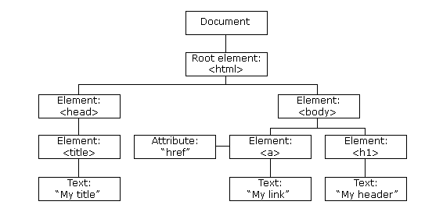

Because of the Document Object Model, JavaScript is able to access all the HTML elements in the page- creating a more dynamic HTML. JavaScript will have the power to alter all HTML elements and attributes in the page, including its CSS styles. JavaScript will also be able to add and delete HTML elements and attributes. Event handling could also be performed because JavaScript will be able to react on these HTML events and also add new HTML events in the page.